**Manuscript ID: IJEHS-2107-1031**

**Answers to reviewers**

**Dear Editor,**

Thank you for giving us the opportunity to send the revised draft of the manuscript ‘**Prevalence of Prehypertension in Nigeria: a Systematic Review and Meta-analysis’ for publication in the** **International Journal of Epidemiology and Health Sciences. We are particularly grateful that you gave us this opportunity despite the major revisions obtained by the manuscript from the reviewers. We appreciate the time and effort you and your reviewers dedicated to providing insightful feedbacks to improve the quality of the manuscript. We have revised the manuscript according to the feedback from the reviewers with the changes highlighted in the manuscript. Please see below, in blue, for a point-by-point answers to the reviewers’ comments. All page numbers refer to the revised manuscript.**

**Reviewers' Comments to the Authors:**

**Reviewer #1:**

1. Running title is missing.

Authors’ response: Thank you for pointing it out. Running title has been inserted.

1. Keywords: "Prehypertension", not "Pehypertension".

Authors’ response: The typographical error has been corrected on page 2, line 3

. Thank you

1. The references must follow the Journal's instruction (Vancouver) with numbers in the text and at the end of article. Please correct it.

Authors’ response: The referencing style has been corrected to Vancouver throughout the manuscript

1. Introduction must be at least 3-4 paragraphs.

Authors’ response: Introduction has been expanded to 4 paragraphs on pages 2-3

1. Search strategy: Start and end data of search must be clear.

Authors’ response: Date stated on page 4, lines 11 & 12. Text reads:

‘*’Searches were conducted between 4rth March 2021 to 15th March 2021’’*

1. Who did data extraction? Were they independent?

Authors’ response: stated on page 6, line 5. Text reads:

‘*’Data extraction was independently done by two reviewers (MAB and AHY)’’*

1. What was the program for data extraction: Microsoft Excel?

Authors’ response: Stated on page 5, lines 8-9. Text reads:

‘*’Data was entered into Excel and then imported into R statistical environment for statistical computing, version 4.1.0’’*

1. The used tests for analysis?

Authors’ response: Test mentioned on page 5, lines 9-12. Text reads:

*‘’Metafor Package was used to fit Random Effects Model for pooling prevalences and Mixed Effects Model for meta-regression using inverse variance method with correction of pooled estimate and its variance using Sidik-Jonkman’s estimator for between study heterogeneity’’*

1. Figure 3.1 is better to move to method section.

Authors’ response: The figure has been moved to method section [page 8]

1. Figure 3.2: What does "setting" mean?

Authors’ response: ‘setting’ was meant to mean rural or urban settlement. The word has been replaced with the word ‘settlement’ throughout the manuscript.

1. Reference for "Sidik-Jonkman’s estimator" is missing.

Authors’ response: The ‘Sidik-Jonkman’s estimator’ has been properly referenced on page 24, reference number 13

1. There is no explanation about "influence analysis" in method section.

Authors’ response: Explanation of influence analysis given on page 6, lines 16-27. Text reads:

*‘’individual studies were investigated for influencers defined as follows:*

1. *Based on hat value, which is standardized distance of each study’s reported prevalence from the pooled prevalence,*
2. *Based on rstudent, which is standardized distance of the predicted prevalence for each study from the pooled prevalence*
3. *Based on Cook’s distance, which is the distance between the pooled prevalence when the individual study is included and when it is excluded and*
4. *Based difference in fits (diffits) which is also a distance between pooled prevalence with the study included and when the study is excluded but in standard deviation units. Cut off values implemented in the R metafor package were adopted. Influential studies according to these cut-off values were marked red in the generated influence plots’’*
5. The reliability of pooling various studies?

Authors’ response: The reliability of the pooled estimate was explained by explaining the substantial heterogeneity on page 14, lines 3-9. Text reads:

*‘’A meta-regression model was fitted using region of the study only and then the region, settlement, mean age and sample size of the included studies as predictors. The value of tau2 dropped from 0.017 in the model without the predictors to 0.002 (a 91% drop). The change in I2 is equally dramatic from 98.6%, signifying substantial heterogeneity, to 70.3% indicating moderate heterogeneity. This means most of the heterogeneity between the studies results from the differences in study characteristics’’*

1. Discussion is relatively short.

Authors’ response: the discussion has been expanded from the initial two paragraphs to six on pages 19-22

**Reviewer #2**:

* 1. The write up is technically not in the expected level of a meta-analysis. Some major components of a meta-analysis (such as summary of critical appraisal of the included papers, analysis of heterogeneity and publication bias) are lacking. I believe this is not suitable for publishing.

Authors’ response: We completely agree that the initial manuscript is at a low technical level. We thank you for taking your time to review the article and make comments which definitely made the manuscript a lot better. We are grateful.

* 1. The criteria by which you screened and excluded or included the studies is not elaborated

Authors’ response: We further elaborated the screening criteria on page 4, lines 4-8. Text reads:

*‘’We included community-based studies conducted in adult population (greater than 18 years of age) of Nigeria. Studies selected defined prehypertension as systolic Blood Pressure (BP) of 120-139mmHg and/or diastolic BP of 80-89mmHg. We excluded studies conducted in individuals less than 18 years of age, studies on pregnant women and all hospital-based studies’’*

* 1. You have not provided the methodological features and the critical appraisal of the 64 included studies in an integrated table.

Authors’ response: We provided the method of appraising the included studies on page 5 as well as the results of such appraisal in an integrated table as a supplementary material. Text reads:

*‘’The methodological quality of the included studies was assessed using a modification of the Joanna Briggs Institute (JBI) Critical Appraisal Checklist for Studies Reporting Prevalence Data9. The item’s original 9 questions were reduced to six (6) with each question given a score of one (1) for a ‘yes’ and zero (0) for a ‘no.’ The total maximum score is six. A study was judged as good quality if it scored minimum of five (5) and of poor quality if it scores less than five (5). Assessment was done independently by two reviewers (AIH and MM) with disagreements sorted by AHY. Table 1 shows the modified tool used in critical appraisal of the included studies. The minimum sample size for scoring a study as a ‘yes’ was three hundered and twenty three (323) calculated using Epitools online calculator10 assuming an estimated prevalence of 30% based on a recent meta-analysis of studies conducted in Nigeria6. Only studies judged as having high methodological quality were included in the quantitative analysis.*

*Table 1 Modified JBI Critical Appraisal Checklist for Studies Reporting Prevalence Data*

|  |  |  |  |
| --- | --- | --- | --- |
| *S/N* | *Question* | *Yes = 1* | *No = 0* |
| *1* | *Was the sample frame appropriate to address the target population?* |  |  |
| *2* | *Were study participants sampled in an appropriate way?* |  |  |
| *3* | *Was the sample size adequate?* |  |  |
| *4* | *Were the study subjects and the setting described in detail?* |  |  |
| *5* | *Were valid methods used for the identification of the condition?* |  |  |
| *6* | *Was the condition measured in a standard, reliable way for all participants?* |  |  |
| *Total Score* | |  | |

*Out of the 63 included in the qualitative analysis, only 21 were judged of good quality and included in the quantitative analysis.’’*

* 1. The heterogeneity index is over 98%. In such a high heterogeneity, running a meta-analysis is not recommended, Moreover, you have not attempted to explain the heterogeneity.

Authors’ response: The substantial heterogeneity was explained on page 14, lines 3-9. Text reads:

*‘’A meta-regression model was fitted using region of the study only and then the region, settlement, mean age and sample size of the included studies as predictors. The value of tau2 dropped from 0.017 in the model without the predictors to 0.002 (a 91% drop). The change in I2 is equally dramatic from 98.6%, signifying substantial heterogeneity, to 70.3% indicating moderate heterogeneity. This means most of the heterogeneity between the studies results from the differences in study characteristics’’*

1. Publication bias has not been evaluated.

Authors’ response: Publication bias was evaluated on page 16 using the plot below

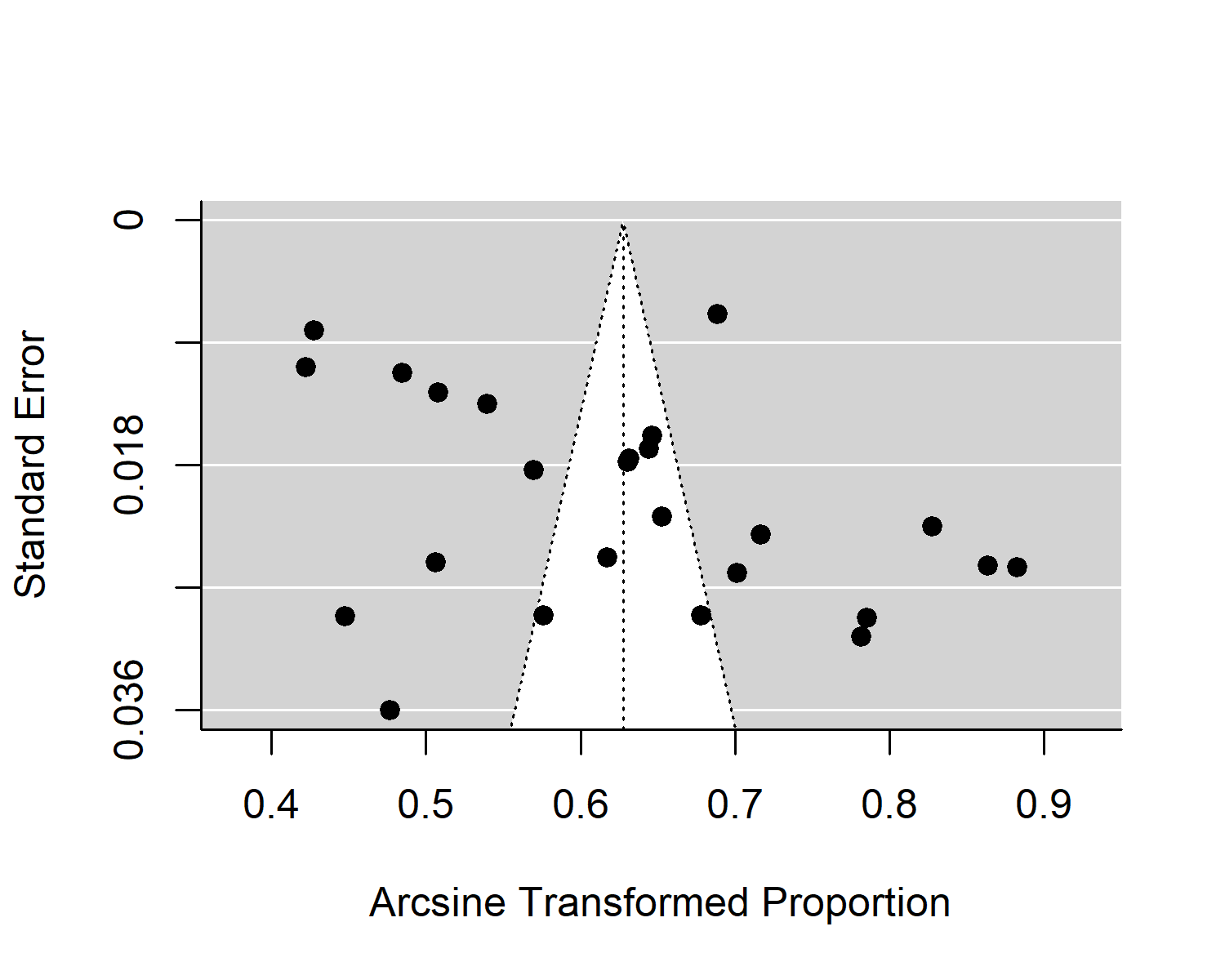

*Funnel Plot*

Formal test for plot asymmetry (regression test) was conducted and it was not statistically significant (*P* value = 0.079), confirming the visual assessment of the funnel plot [page 16].

1. The referencing style of IJEHS has not been followed.

Authors’ response: The referencing style has been changed to Vancouver throughout the manuscript

**Reviewer #3:**

* 1. The references must be revised based on the journal's rules.

Authors’ response: The referencing style has been changed to Vancouver throughout the manuscript. Thank you.

* 1. I am afraid of high heterogeneity with no appropriate explanation.

Authors’ response: The substantial heterogeneity was explained on page 14, lines 3-9. Text reads:

*‘’A meta-regression model was fitted using region of the study only and then the region, settlement, mean age and sample size of the included studies as predictors. The value of tau2 dropped from 0.017 in the model without the predictors to 0.002 (a 91% drop). The change in I2 is equally dramatic from 98.6%, signifying substantial heterogeneity, to 70.3% indicating moderate heterogeneity. This means most of the heterogeneity between the studies results from the differences in study characteristics’’*

Thank You

M. A. Bashir1,*

A. I. Yahaya1

Mukhtar Muhammad1,

A.H. Yusuf1

Department of Anatomy Bayero University Kano  
*Author of Correspondence, Email: [musabashir34@gmail.com](mailto:musabashir34@gmail.com), GSM: +2347036878467